**MySQL Assignment-1**

Create table1 as worker with their ID,first name ,last name ,salary,joining date , department & table 2 Bonus with workers ref ID, Bonus date ,Bonus amount and table 3 Title with worker ref ID ,worker title.fill the details in each row of tables by making use of DDL & DML commands.

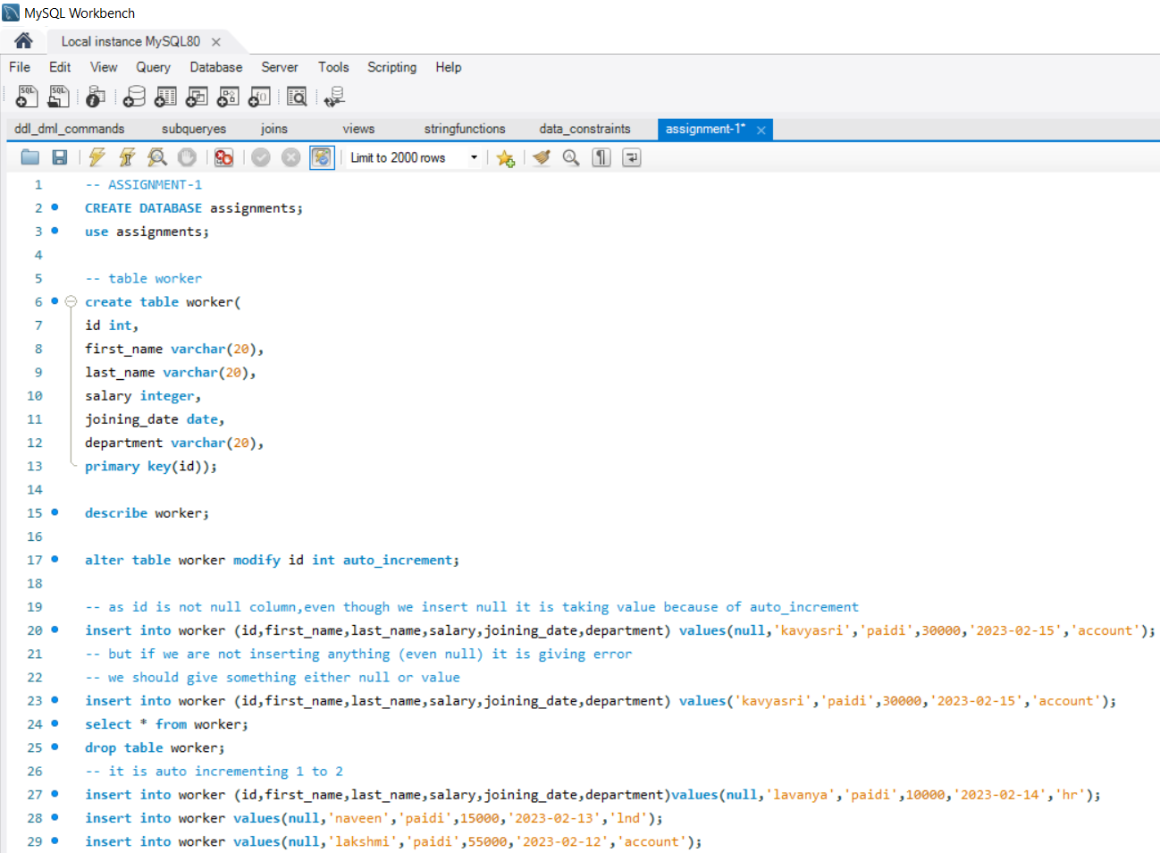

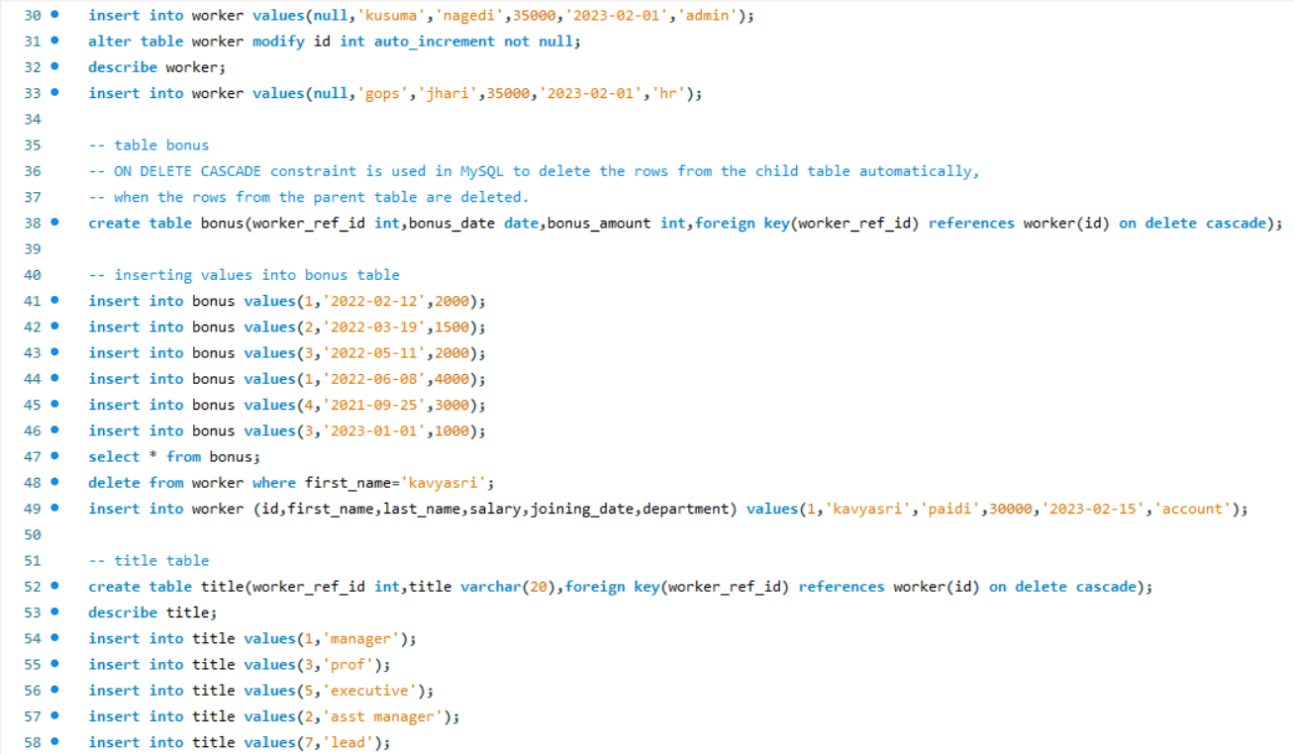

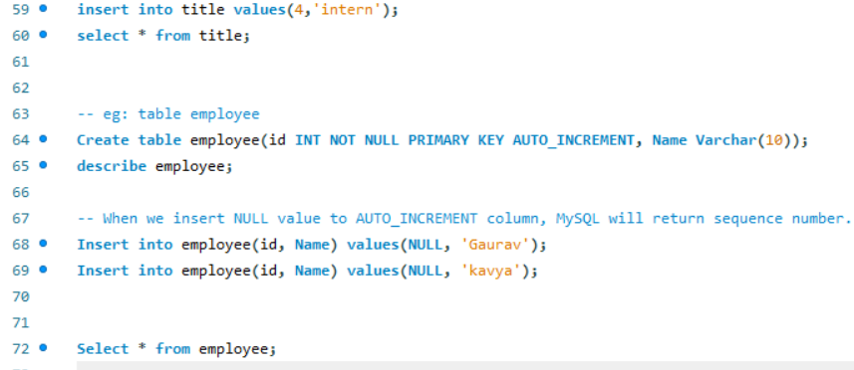

**OUTPUTS**

1. Worker table

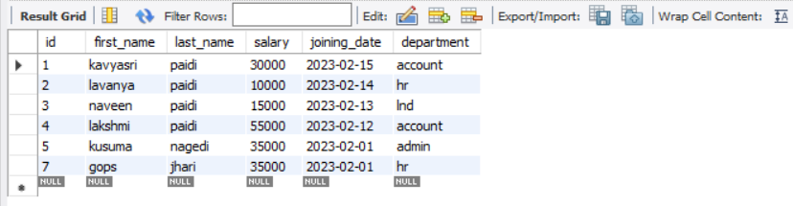

1. Bonus table

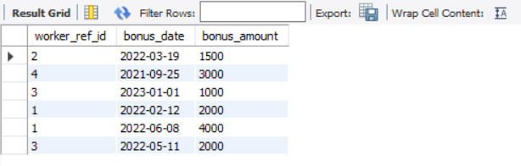

1. Title table

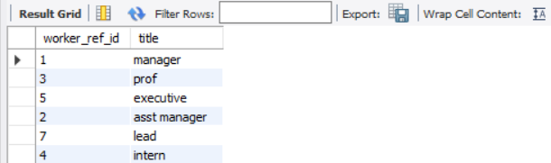

1. Employee table

